# Urban Threads — Diagrams

Sitemap and file/folder structure for Part 1.

## Sitemap

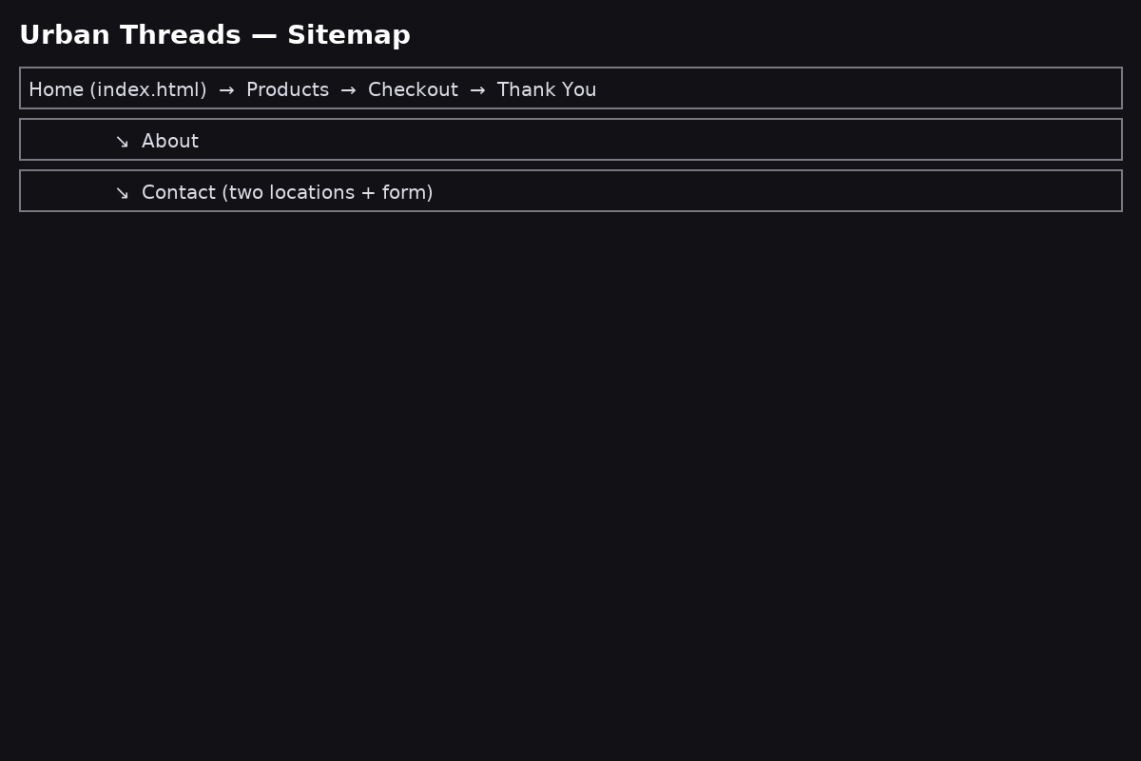

## File & Folder Structure

